Designing and Testing a Robot

San José State University

Charles W. Davidson College of Engineering

ENGR 10 Introduction to Engineering

Yu Cao, Timothy Davis, Khan Do, Hungyi Lin,Chenghui Xue

Lab Section 13

Professor Steven Sepka

December 9 , 2016

**Project Summary:**

The objective of this project was to design, build, and program an autonomous robot that had a simple task to perform. The robot’s goal was to be able to move to an object inside a small enclosure, or “arena,” interact with it, then move to another object and take that object out of the arena. This process would simulate the necessary design and engineering decisions necessary to build a simple autonomous robot that needs to interact with its environment. For this project, a “Red Beacon” and a “Green Beacon” were to be the two objects that the robot was to interact with. The Red and Green Beacons were small containers with a switch on top and an infrared-emitting circuit board inside.

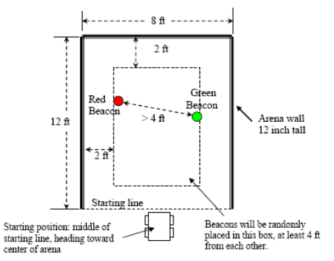

**Figure 1.** Arena dimensions and Red and Green Beacon position rules. Taken from robot Project Guidelines at http://engineering.sjsu.edu/e10/wp-content/uploads/RobotProjectGuidelines-F14.pdf

The mechanical structure of the robot was built using a VEX robotic kit. Three motors, two wheels, and various rectangular slotted metal pieces were combined with tiny screws to form the structure. After being connected with a controller that stored a program, the robot could move forward, backwards, turn clockwise or counterclockwise, and lift a mechanical arm that could be lifted vertically or set down. An Infrared Receiver(IR) Board was assembled and placed in the front of the robot to read the intensity of light emitted by the detectors. Also, two bumper switches on the back of the robot were used to detect collisions while backing up.

Then the EasyC software, a C-based language, was used to write and upload a program to the VEX controller, which was used to receive and send analog and digital signals to and from the mechanical components on the robot. The VEX controller was connected to a computer using a double-sided USB cord.

Because of the various tasks and fields of engineering involved in the project, the team learned cooperation skills, as well as mechanical, electrical, and software practical skills to achieve the project objective.

**Table of Contents:**

Project summary…………………………………………………………………………….…..1

Introduction……………………………………………………………………………………....3

Design Description:

IRB assembly process……………...………………………………………………………….7

Robot assembly process…..…………………………………………………………………..8

Software….…………………………………………………………………………………….12

Design performance….……………………………………………………………………….12

Conclusions………………………………………………………………………………….....15

Recommendations for Future Work………………………………………………………….15

Reference……………………………………………………………………………………....15

Appendix

* Appendix A - Program Flow Chart…..……………………………………………….17
* Appendix B - Teamwork Evaluation………………………………………………….19

**Introduction:**

The purpose of the lab was to design, build, program, and test the performance of a robot. The project was divided into two components: build the robot and test the performance of this robot. The robot consisted of three main parts: mechanical construction, Infrared Receiver Board (IRB) fabrication, and programming. The objective was to design a robot which can shut down the Red Beacon (See **Figure 1**), and move the Green Beacon out of the arena, across the starting line (See **Figure 2**).

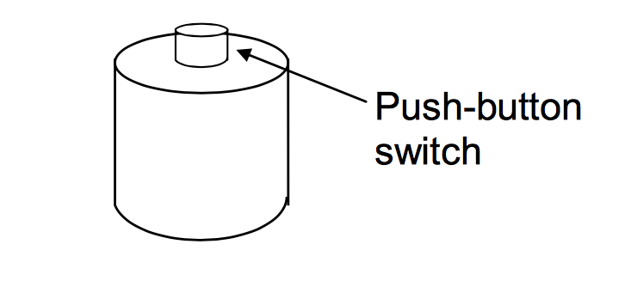

**Figure 2.** Infrared beacon. The infrared emitting beacon can be turned off by pushing down on the push-button switch on the top of the beacon. Taken from robot Project Guidelines at http://engineering.sjsu.edu/e10/wp-content/uploads/RobotProjectGuidelines-F14.pdf

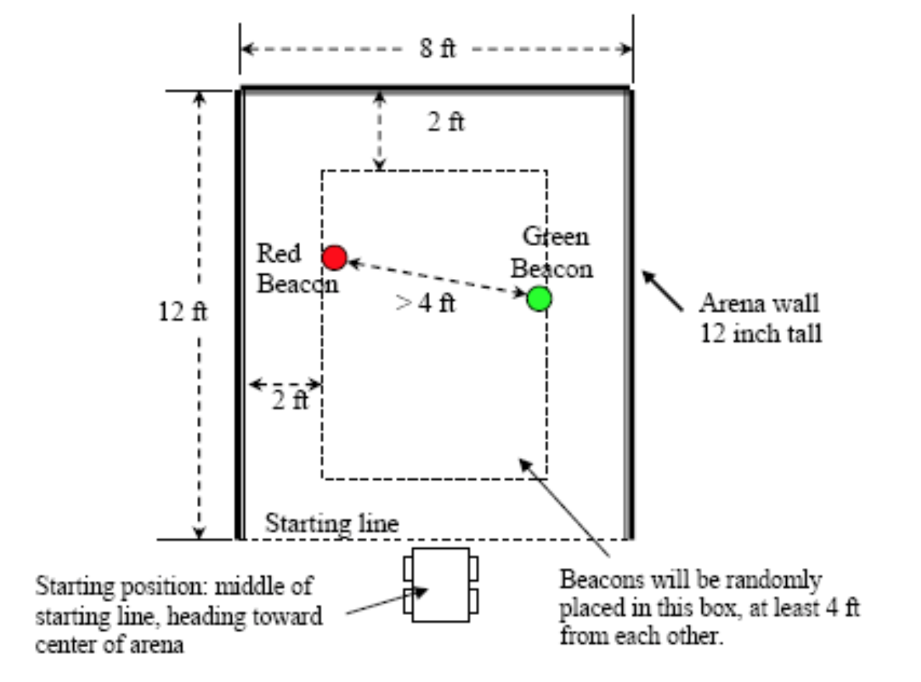

**Figure 3.** The arena of the robot project. The robot must enter the arena, find and turn off the red IR beacon, and move the green IR beacon out of the arena beyond the starting line. Taken from robot Project Guidelines at http://engineering.sjsu.edu/e10/wp-content/uploads/RobotProjectGuidelines-F14.pdf

For this project, the group divided into three sub-teams: one focused on the mechanical construction, software programming, and Infrared Receiver Board (IRB) fabrication.

In the mechanical construction sub-team, instructions were given by the VEX manual to construct the SquareBot in the first week. In the second week, the mechanism for turning the Red Beacon off and for moving the Green Beacon was designed and constructed.

In the Infrared Receiver Board (IRB) fabrication sub-team, directions for where each component should be placed and soldered were given on how to build the Infrared Receiver Board (IRB). (See **Figure 3**)

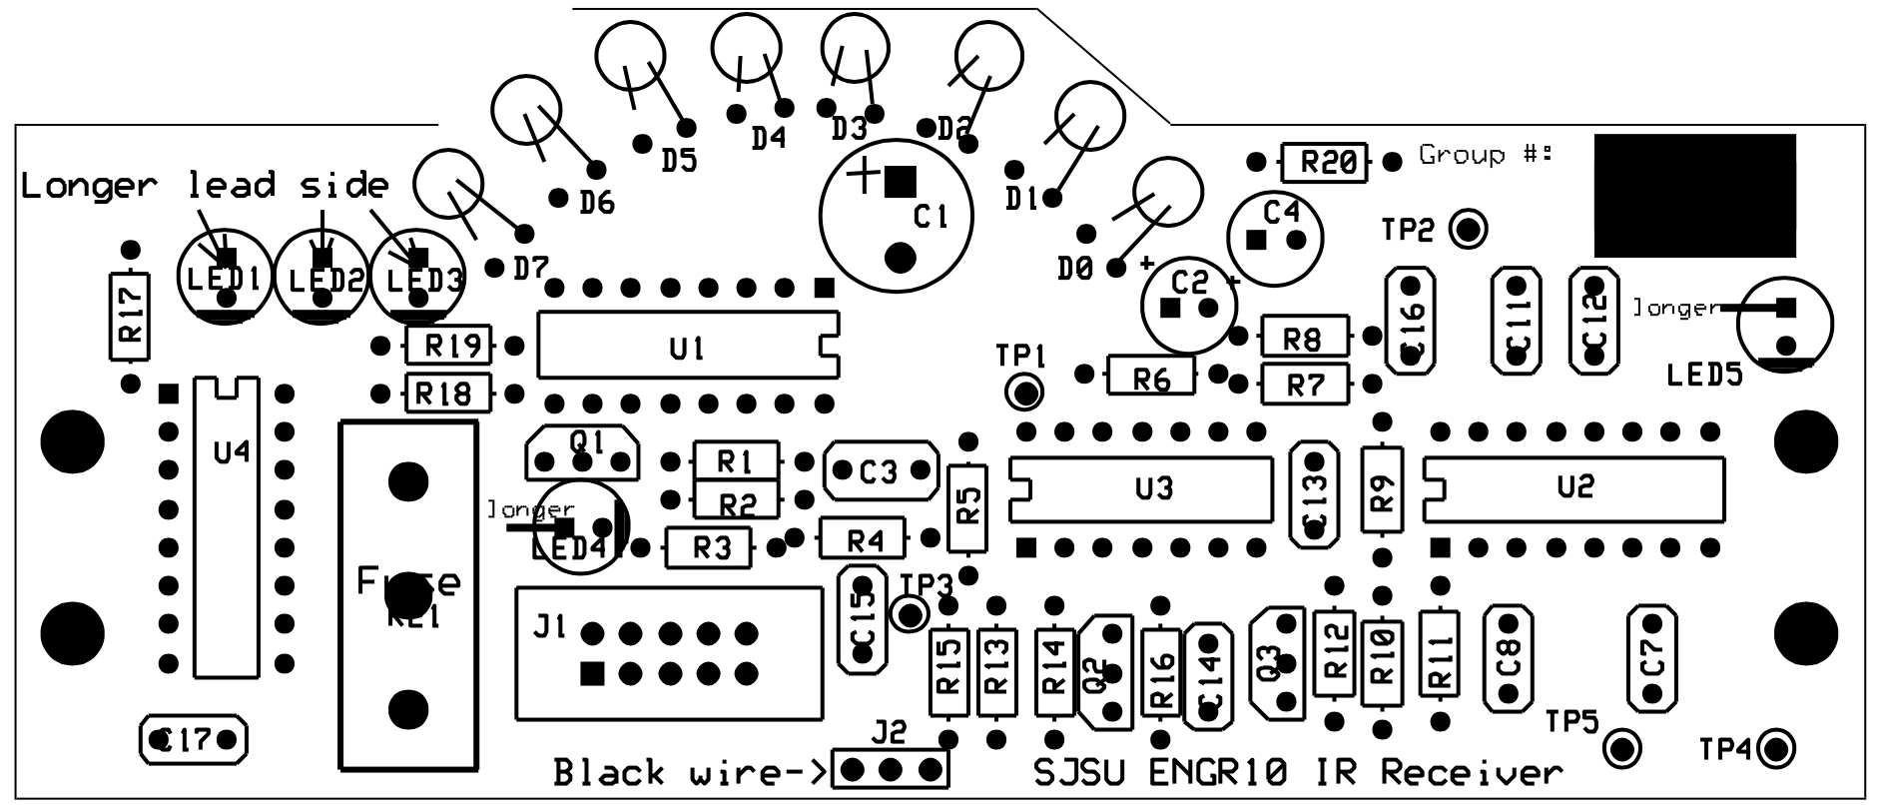**Figure 3.** Component layout diagram of the Infrared Receiver Board (IRB). Taken from robot Project Guidelines at http://engineering.sjsu.edu/e10/wp-content/uploads/RobotProjectGuidelines-F14.pdf

In software programming sub-team, the program was written with EasyCPro language to control the robot. The program was used to interact with the VEX controller’s input and output ports, where devices such as motors, switch detectors, and the IR Board could be connected.

**Design and Assembly Description:**

**IRB Process**

The Infrared Receiver board served as the “eyes” of the robot. The board consisted of resistors, capacitors, transistors, infrared detectors, LEDs, and integrated circuits. By a method called soldering, the components were attached to the circuit board. Soldering uses a low-melting alloy to join less fusible metals without heating the objects to the melting point. Soldering is important in this process because it allows for a practically permanent connection between the circuit board and the components but can also be reversed when needed. Unlike welding, soldering doesn’t melt the pieces together, but rather, it creates a connection using a filler metal. (See Figure 4)

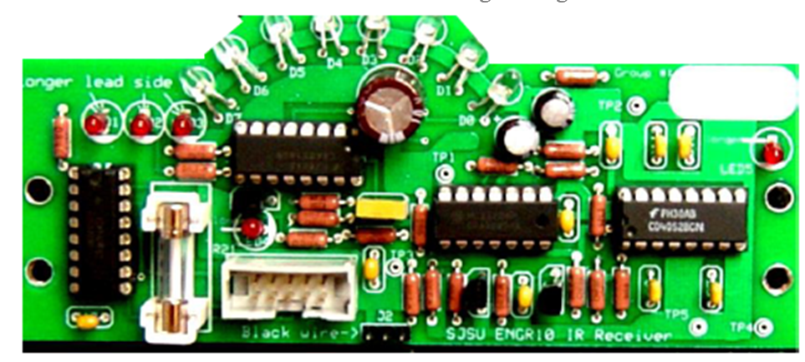

**Figure 4.** A complete IR board with all components attached.

One of the components of the IR board are the 8 infrared detectors. The infrared detectors can sense the light emitted from the beacons to signal where the robot should move. They are also polarized meaning that there is a specific orientation they must be soldered in. The short lead is on the left and the long lead on the right. (See Figure 5)

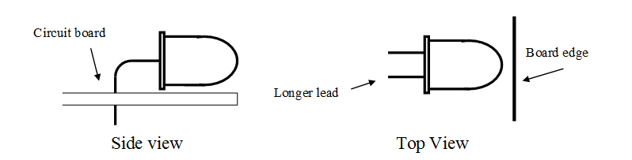

**Figure 5.** Placement of the infrared detectors.

Resistors were also used in IR board assembly. Resistors weren’t polarized so their orientation didn’t matter on the board. Resistors were the most abundant of the components so extra care went into reading component IDs and values. Capacitors functioned as a tiny rechargeable battery for the circuit board in that it could store and release energy. They have various purposes like filtering, tuning, and separating signals. Some capacitors we used for the board were polarized but not all. (See Figure 6)

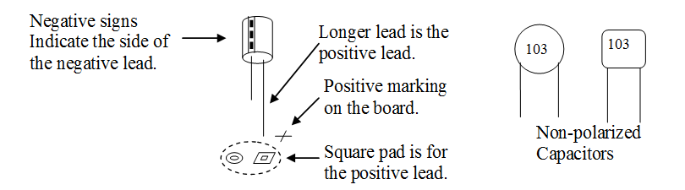

**Figure 6.** The correct orientation for polarized capacitors and shapes of non-polarized capacitors.

The integrated circuits were easiest to identify and attach to the board because there were only two types, the 16-pin and 14-pin. The integrated circuits were attached to their sockets with the notches oriented in the same direction. (See Figure 7) Five red colored LEDs were soldered to the board with the anode (longer lead) going into the square, and the cathode (shorter lead) going into the circle. The 5 LEDs serve as status indicators for the active IR detectors, tuning frequency, and sensitivity setting.

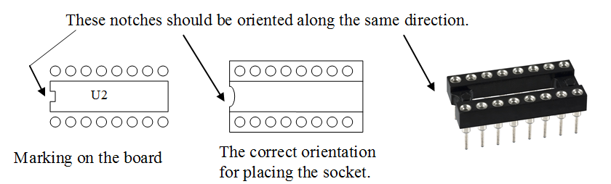

**Figure 7.** Orientation of integrated circuits.

Lastly, the two connectors were attached to the board. They were both soldered to the board with the shorter pin side down. One of the connectors would connect the board to the VEX controller and the other would connect the board to the battery.

Of all the components, it was crucial that the infrared detectors, integrated circuits, and transistors were placed in the correct orientation. Each of these components played a fundamental role in the operation of the IR board and would cause a malfunction if placed in the wrong orientation. The infrared detectors gave the robot direction by sensing the infrared light from the beacons. The integrated circuits functioned as a timer, amplifier, oscillator, counter, computer memory, and microprocessor. The transistors were used for signal amplification, switching, and voltage regulation.

**Robot Assembly Process**

The square body of the robot was modeled after the robot in the instruction manual. However, the placement of the battery, circuit board, and arms were unique. The protruding metal pieces in the front of the robot were designed to secure the beacon in a position so that the arm could either turn off or grab the beacon. The robot built contained two motors, one for the wheels on the right and one for the wheels on the left. (See Figure 8)

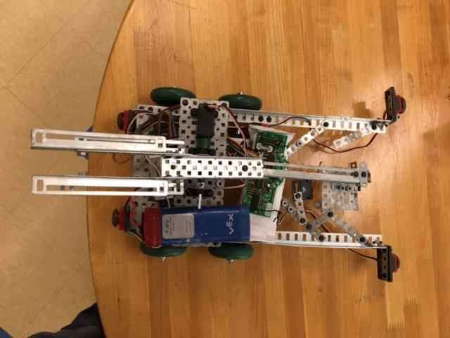

**Figure 8.** Top view of robot.

One servo was used to control the robot’s arm. The servo was place on the top metal piece of the robot and was connected to the arm. After noticing that the servo had some difficulty lifting the arm, the team attached counterweights to make it easier for the servo to lift the arm. (See Figure 9)

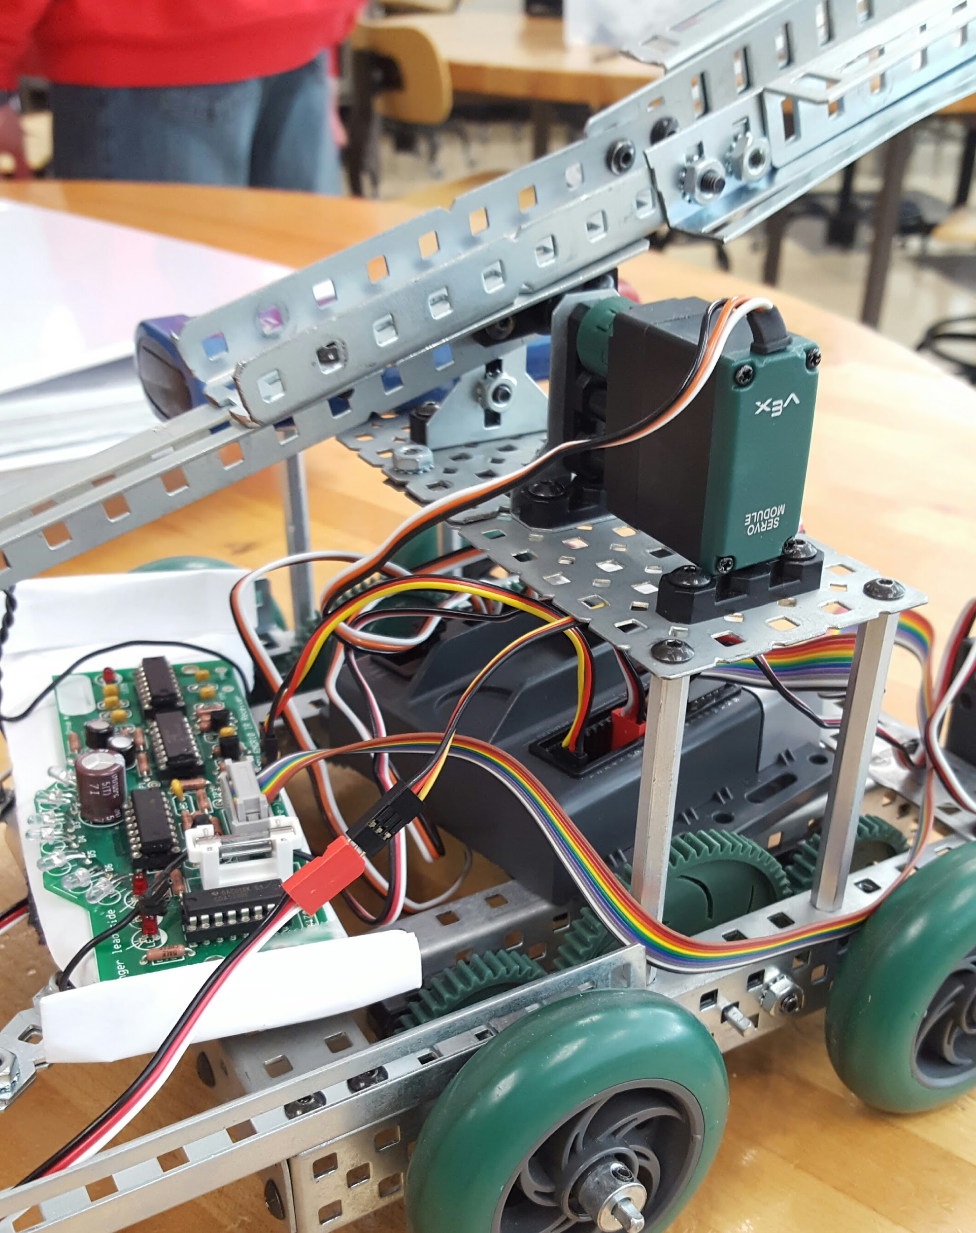

**Figure 9.** The servo attached to the robot’s arm.

Five sensors were installed on the robot. Three sensor were in front and two in the back. The types of four of the sensors chosen were bumper switches. The final sensor was a limit switch on the front of the robot, near the center. The design of the robot was made to push a beacon into the limit switch if hit from the front. The two bumpers switches in the front of the robot didn’t serve as switches to guide the robot, only the back switches did. One of the front bumper switches was set up to be a “Start” button to reduce the trouble of reaching in the back of the controller to turn the robot on and off, which was especially difficult while the robot was moving. The back switches were installed just in case the robot were to hit the wall as it was pulling the Green Beacon out of the arena. During testing, the robot only hit the wall with the back bumpers half of the time, but it was a feature installed to ensure the robot would complete the required tasks in every run. (See Figure 10 and 11)

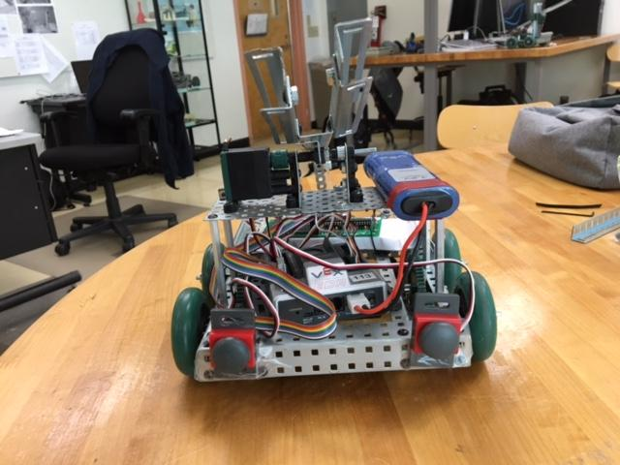

**Figure 10.** The back view of robot. The back bumper switches were used to detect collisions while backing up.

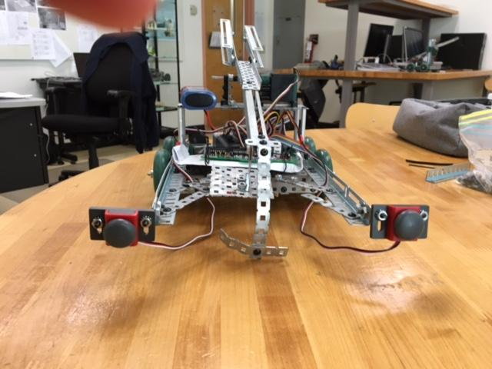

**Figure 11.** The front view of robot. One acted as a “Start” button. The limit switch is placed behind the top arm, near the center of the robot.

The components of the robot were connected to the VEX controller by cables. There were three main sections for cables to be inserted into the VEX controller: the “Motor” output section, the “Analog” input section, and the “Digital” input section. All of the motors were connected to the “Motor” output section of the controller. One part of the IR Board was connected to the controller as an analog signal. All of the switches and most of the IR Board connections, however, were connected through the digital input ports of the controller. (See **Figure 12**)

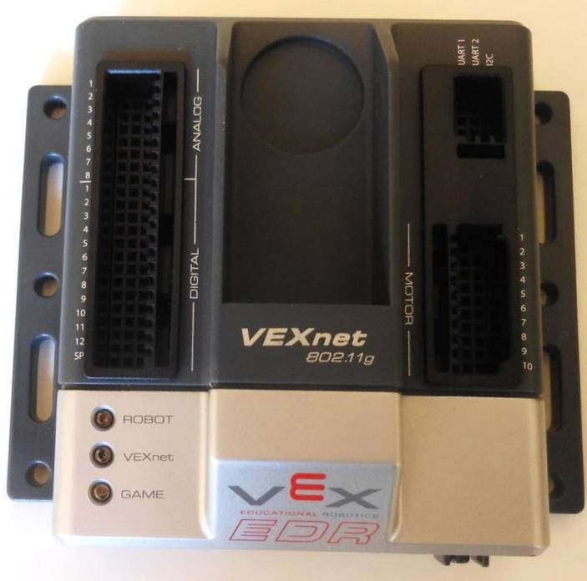

**Figure 12.** The VEX controller with the three main input/output port sections: “Motor,” “Digital,” and “Analog”

**Design Test and Performance:**

The purpose of our project is to turn off the Red Beacon and move the Green Beacon across the starting line. The robot was able to accomplish all the specified tasks. It took the robot 26.11 seconds to finish the task. The design also allowed for one bumper switch to start and stop the whole program. Code was added to hit the switch on the Red Beacon more than once until it was turned off.

However, there were still problems in the performance. Instead of moving in a straight line towards a beacon, the robot wobbled back and forth while travelling towards the beacon. The issue is likely due to the different placement of the wheels, differences in the motors used, or other small differences in our robots design from what the movement code provided was designed for.

**Software:**

The program was designed to perform four main steps: find the Red Beacon, turn it off, find and capture the Green Beacon, and bring it out of the arena. To accomplish this, a high level algorithm was implemented (See **Figure 13**).

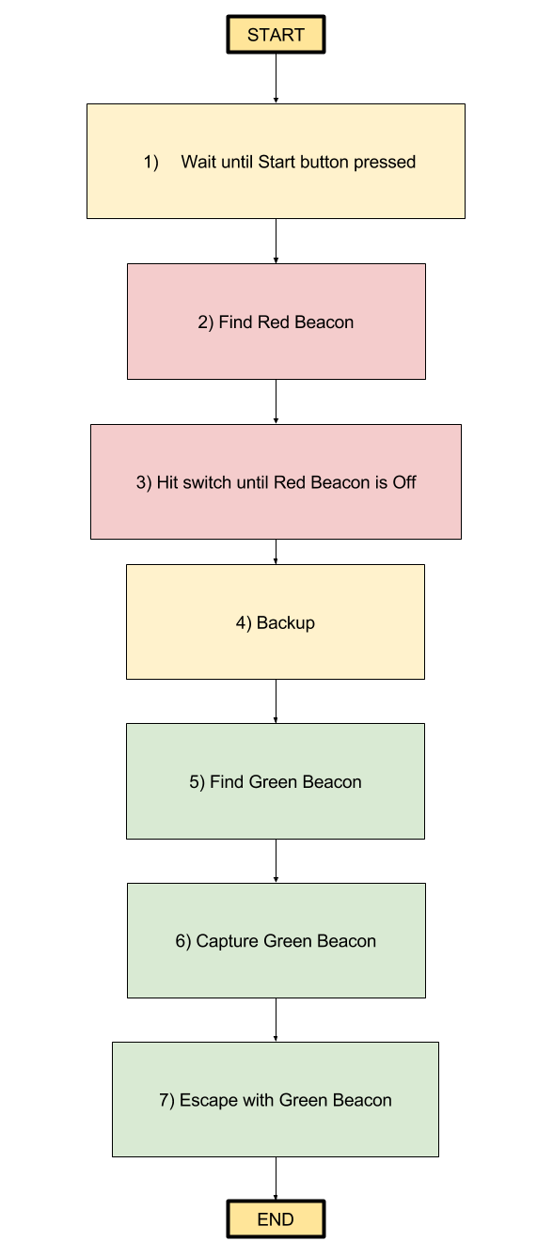

**Figure 13.** High Level Algorithm Flow Chart.

After being turned on, the robot would be placed outside of the arena and wait until a “Start” button was pressed (this button was set to be one of the front bumper switches on the robot). After the Start button was pressed, the program would lift the top arm and attempt to find the Red Beacon.

To find the Red Beacon, a frequency variable was set to zero, indicating the the program should look for the Red Beacon. The input from the photodetectors was read and the maximum value was used to determine which direction the robot should move toward. By checking the sum of the values of the photodetectors, the intensity could determine how close the robot was to the signal. Our program checked that if the intensity was high enough or the front limit switch was pressed, this would mean that the Red Beacon was either very close to the robot or the front of the robot hit the Red Beacon, and the robot should stop.

Once near the Red Beacon, the program was designed to hit the switch on top of the Red Beacon. To do this, the robot lifted the top arm by setting the servo motor to the up setting (for our program, a value of -127), then putting it to down setting (a value of -30), and finally back up again. The photodetectors would the signal again after waiting two seconds and while the Red Beacon was still on, the program would repeat this process. The program checked whether the Red Beacon was off by checking that the sum of the photodetectors was less than a preset ambient light level.

After determining that the Red Beacon was off, the robot was to backup for one second. This was done so that the robot would have room to start looking for the Green Beacon. The process of finding the Green Beacon was identical to finding the Red Beacon, only that the frequency variable was changed to 1 before looking for the signal.

Once the robot reached the Green Beacon, the top arm was put to the down position. With the Green Beacon successfully captured, the last step was to have the robot take the Green Beacon out of the arena. The program did this by slowly backing up. If at any time the “Start” button was press, the robot would stop and the program would end. This let the team easily turn off the robot once it successfully escaped the arena. However, if while the robot was backing up, if either of the back bumper switches was pressed, this would mean that the robot did not escape, and hit a wall of the arena. If the robot hit a wall, it would stop, move forward for half a second, turn counterclockwise for half a second, then continue backing up. It would repeat this until the “Start” button was pressed, and the robot stopped and the program was ended.

**Conclusions:**

This project called for a robot to shut down the Red Beacon, and move the Green one across the starting line. It is consisted of three main phases: mechanical construction, Infrared Receiver Board (IRB) fabrication, and programming.

In mechanical construction, the VEX robotic kit was used to build the physics part of robot. There were three motors used: two for wheels and one for the top arm used to hit a beacon’s switch and capture the Green Beacon. The arm we designed to successfully shut down the red beacon. The shape of the arm and the frame of the robot was used to secure the Green Beacon and move it across the line.

In Infrared Receiver Board(IRB) fabrication phase, the Infrared Receiver(IR) Board was constructed and placed in front of the robot, which read the intensity of light reaching the detectors. Switches on the robot were used to detect collisions with walls and the beacons.

In the programming phase, the EasyC software was used to program the controller. The program was written in the EasyC compiler and downloaded into the VEX controller. With the program in the VEX controller, the robot was able to finish the tasks: shut down the Red Beacon and to move the Green one across the starting line.

In this project, the team experienced how to construct a robot, learned how to build a Infrared Receiver Board(IRB), and learned some programming. The team also learned how to cooperate with teammates.

**Recommendations for Future Work:**

Building a place to store battery was one thing that we could improve. There was no place to store battery on the robot, and during the test, sometimes the battery dropped to the floor when there was a big movement. Eventually, we used tape to fix the battery in place. However, the robot would look more professional if there was a specific place for battery.

Also, making the front side of arm lighter was another thing that could have been improved. Sometimes the arm could not lift high enough, especially when the battery was low. When the arm couldn’t lift high enough, it grabbed the red beacon after turned the red beacon off. Eventually, this problem was solved by adding a few metal pieces on another side of arm as a counterweight. The front side of arm lighter could be made lighter by replacing the square shape metal piece which pressed the button of the Red Beacon with another, lighter material. For example, we could use cardboard to replace that piece.

**References:**

[1] Robot Project Guidelines [PDF document]. Retrieved from

http://engineering.sjsu.edu/e10/labs/robot/

**Appendices:** Appendix A: Algorithm Flow Chart:



Appendix B:

i. Who worked on each aspect of the project :

Soldering: Hungyi Lin, Khan Do

Mechanical design and construction tasks: Yu Cao

Programing: Timothy Davis, Chenghui Xue, Hungyi Lin

Testing: all members

ii. Who contributed to each section of the report

|  |  |
| --- | --- |
| Summary | Chenghui Xue |
| Introduction | Yu Cao |
| IRB process | Khan Do |
| Robot assembly process | Khan Do |
| Software | Timothy Davis |
| Design Performance | Chenghui Xue |
| Conclusions | Yu Cao |
| Recommendations for Future Work | Hungyi Lin |
| Proofreading | Timothy Davis |
| Appendix B | Hungyi Lin |

iii. Describe one challenge the team faced, how the team resolved it, and a lesson the team learned from that experience.

One challenge that our group faced was the senors on IR board could not detect both beacon if the beacons are placed a little bit far. We solved this challenge by changing mechanical design and some code. In the beginning, the level of IR board is higher than the beacons. So, we changed the design of the robot to make IR board and beacons stay in same level. Beside, the ambition level in the code was adjusted from 200 to 45. It made the sensors have ability to detect weaker signal. By changing these two part, the sensors could detect signal from further distance. The lesson we learned from this experience is that the thing can be improved in multiple ways.

**Teamwork Analysis:**

|  |  |
| --- | --- |
| Teamwork skill | Performance level |
| 1) open and honest communication among members | 4.3 / 5 |
| 2) each individual carried his/her own weight | 3.7 / 5 |
| 3) collaboration in decision making | 4 / 5 |
| 4) team set goals and milestones | 4.7 / 5 |
| 5) people listened to each other | 4.7 / 5 |
| 6) leadership was shared among the members | 3 / 5 |